**Physical appearance data – Mammals**

**Colours**

**Record**: score in categories (For all fur and bare skin on body, legs, tail and head)

1 = Dark (Use for black and white also)

2 = Dull

3 = Light/pale

4 = Mid (standard shade)

5 = Bright

Black, white, grey, fulvous, rufous, buff, russet, blue, red, green, yellow, orange, pink

Multiple shades of brown have been selected as the large majority of mammals bearing a shade of brown. It was decided that it was not accurate enough to simply state ‘brown’ as a colour and note all of these different shades by the numbering system. The shades included are as follows:

1. Fulvous - Described as dull-orange, tawny or beige.



1. Rufous - Described as reddish-brown or brownish-red as that of rust.



1. Buff - Described as light brownish-yellow, synonymous with ochre.



1. Russet - Described as a dark brown with a reddish-orange tinge.

**Overall Impression**

**Record:** Presence as 1 in exclusive categories (below)

Note: This is the overall impression of the mammal’s colouration. If there is a prominent patch of contrasting colour that does not override the overall impression this should be recorded as a prominent patch (see next heading).

Plain = All or predominantly one colour

Bicolour: Ventral vs. dorsal = different colour long spine vs. along belly

Bicolour: Upper vs. lower = differently coloured upper and lower section of the body

Bicolour: Patches = Overall impression of pied colouration, but not ventral vs. dorsal (e.g. Red-flanked duiker)

Tricolour or more = multiple shades of colour without overriding overall impression.

**Prominent patches** = record as 1 if any notable patches present, e.g. bright/unusual colours or sharp contrast. (Not exclusive, is additional to overall impression).

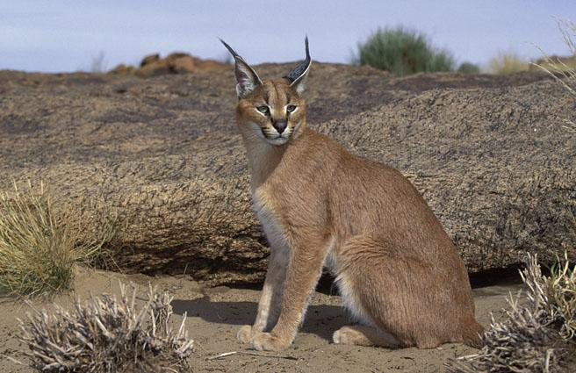**Examples of difficulties:**

Caracal = Bicolour: ventral vs. dorsal, technically tricolour (buff, white and black) but overall impression is of ventral vs. dorsal, black only on ears and patches on face.

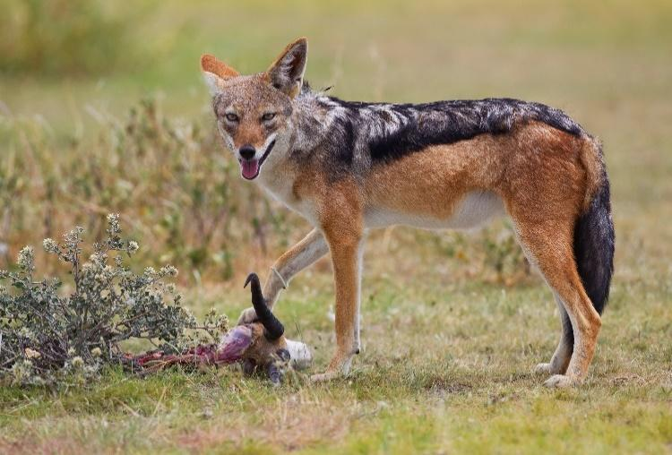

Black-backed jackal = Tricolour or more. May seem to be bicolour: upper vs. lower, but ventral is white (difficult to see in some images).

**Patterning**

**Record:** Presence as 1

Vermiculation= fine stripes or patterns  
Spotted= larger spots  
Speckled= fine spots   
Body streaking/striping= thicker lines or splotches than vermiculation. This also includes rings on tails.

Note that these patterns can occur across the body or on a particular section but if exclusive to the head, this should only be indicated under head patterning.

**Head pattering**

**Record:** Presence as 1

Include patches, stripes, spots, etc that are not present on the rest of the body (as would be included in patterning). Only include any beards or manes, etc… if prominent e.g. striped or different colour. Include these in other unusual adornments.

**Appendages**

**Body length**

**Record:** Absolute value (Head-body length)

**Tail length**

**Record:** Score (Compared to body length, base of neck to base of tail)

1 = short (less than half body length)

2 = medium (approximately half body length)

3 = long (more than half body length)

4 = very long (approximately body length or longer)

If there is anything unusual about the tail, for example being exceptionally thick or patterned, should include in other unusual adornments.

**Leg length**

**Record:** Score (Compared to body length, base of neck to base of tail)

1 = short (less than half body length)

2 = medium (approximately half body length)

3 = long (more than half body length)

4 = very long (approximately body length or longer)

**Eye placement**

**Record:** Score (Eye placement position on skull)

1 = Forward facing (Usually carnivores or omnivores as have need for binocular vision)

2 = Sideways facing (Herbivore)

**Eye size**

**Record**: Score (See below)

1 = Small (0-10% proportion of distance)

2 = Medium (approximately 10-25% proportion of distance)

3 = Large (25+% proportion of distance)

Measurement: ratio of distance between end of muzzle and start of ear to diameter of eye (on the same plane).

Red Line: distance between end of muzzle and start of ear.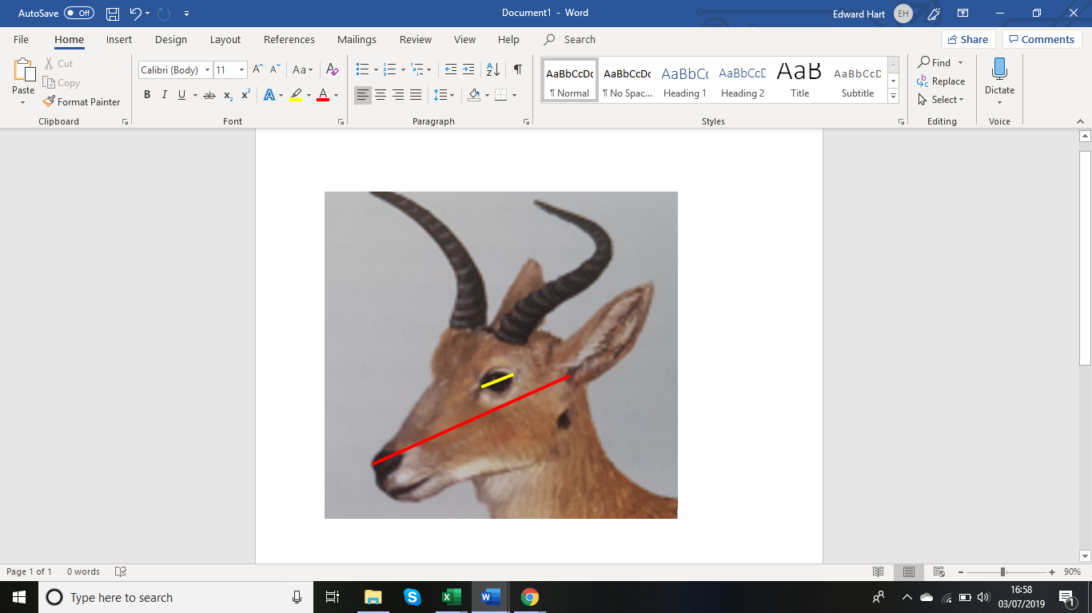

Yellow line: diameter of eye, on the same plane as red line.

In this example, the yellow line is approx. 25% of the red line, so the eye is said to be medium sized.

This methodology can be used for all species we are looking at because they are all presented in a profile plane of view in the ‘Mammals of the World’ books.

**Ear size**

**Record:** Score (Surface area of ear in proportion to size of head half head, end of muzzle to start of ear)

1 = Small (0-25% proportion)

2 = Medium (25-50% proportion)

3 = Large (50-100% proportion)

4 = Very large (100+% proportion)

Example: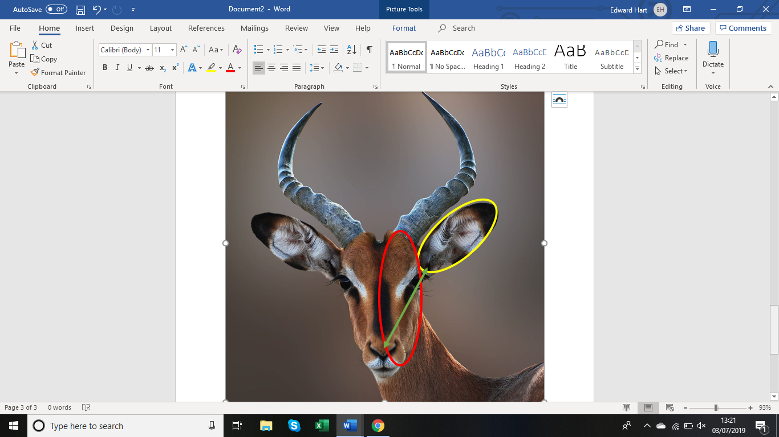

Impala

Green line: Distance from end of muzzle to start of ear.

Yellow circle: Represents the surface area of the ear.

Red circle: Represents surface area of half of the face.

The yellow circle is between 50 and 100% of the size of the red circle, so the Impala has large ears.

Particularly ornate ears (e.g. caracal has ear tufts) could also be noted in other unusual adornments.

**Adornments**

**Presence of horns or antlers**

**Record**: Presence as 1

This includes antlers, but not ‘horn-like’ structures such as tusks. If there is anything particularly unusual about the horns, that does not fit into any descriptive categories (e.g. white tips), could also be mentioned in other unusual adornments.

**Horn/antler length**

**Record:** Absolute value (Length from base of horn to furthest distance from body)

If not available in data set use data of species in the same genus (or family), or similarly morphologically related.

**Horn/antler length estimated**

**Record:** Indicate with 1 if data is used is not that of the species in question.

**Shape of horns/antlers**

**Record:** Score

1 = Straight (e.g. Gemsbok)

2 = Spiralled (e.g. Eland, Greater Kudu)

3 = Curved (e.g. African buffalo, Impala)

Note that spiralled horns are horns that make one complete turn of a spiral.

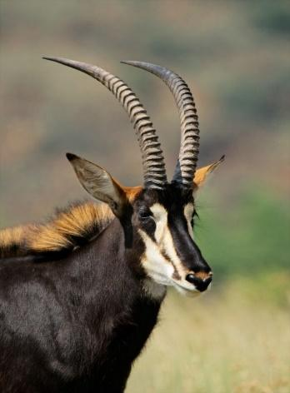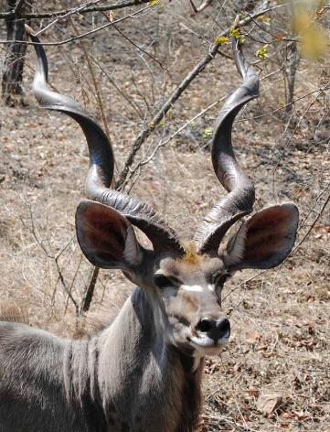

Spiralled horns: Curved horns:

Greater Kudu Sable antelope

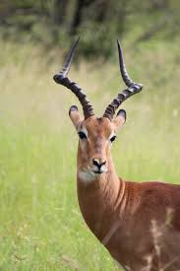

Impala horns are curved as they do not complete a full rotation so are not spiralled.

**Horn/antler surface**

**Record**: Score

1 = Smooth (e.g. Kudu, Bongo)

2 = Ridged (e.g. Waterbuck, Thompson’s gazelle)

**Hornlike appendages**

**Record**: Presence as 1

Protrusions that are similar to horns (but antlers are listed under horns). For example, ossicones (giraffes) or tusks (elephants).

**Muzzle shape**

**Record**: Score (eye to nose distance in proportion to eye to ear distance)

1 = Short snout (0-50% of distance)

2 = Medium snout (50-100% of distance)

3 = Long snout (100-200% of distance)

4 = Very long snout (200%+ of distance)

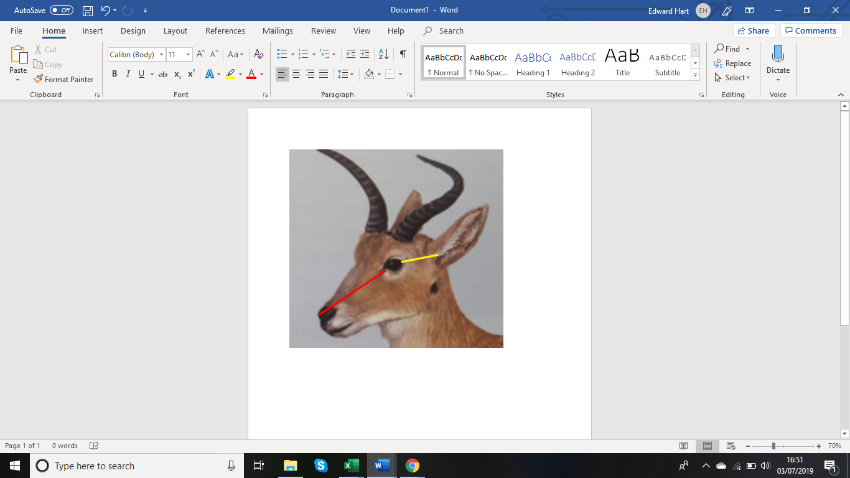Red line: distance from eye to end of nose (muzzle).

Yellow line: distance from eye to start of ear.

In this example, the red approx. 190-200% of the yellow line, meaning this species has a long snout.

This methodology can be used for all species we are looking at because they are all presented in a profile plane of view in the ‘Mammals of the World’ books.

Eye position does affect the measurement, but I believe that animals with forward facing eyes have the appearance of shorter muzzles because of this (as will be reflected in the measurements).

**Proboscis**

**Record**: Presence as 1

Includes any form of elongated snout/muzzle. An elephant’s trunk is the most obvious example, but others include the snout of the aardvark or of the elephant shrew.

**Other unusual adornments**

**Record**: Any features that will make the mammal’s appearance stand out to a tourist.

This includes: Scales, fur tufts (beards, moustaches and manes), prominent patches on face or legs, noticeably coloured eyes, multicoloured horns, tusks, coloured bms on monkeys, etc...

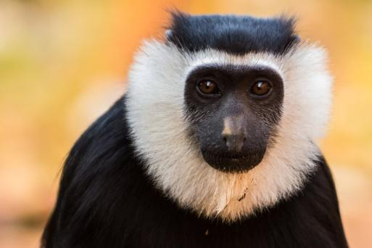

**Some technical terms:**

**Ruff**: Prominent patch of extended fur that usually covers throat but may encircle entire face (Geoffroy’s Pied Columbus), mostly seen in monkeys.

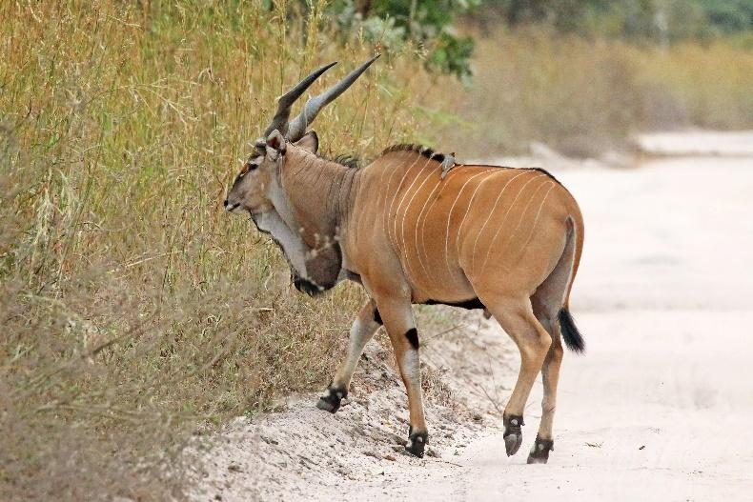

**Dewlap**: A longitudinal flap of skin that hangs below the jaw or neck of come mammals. E.g. Giant Eland.

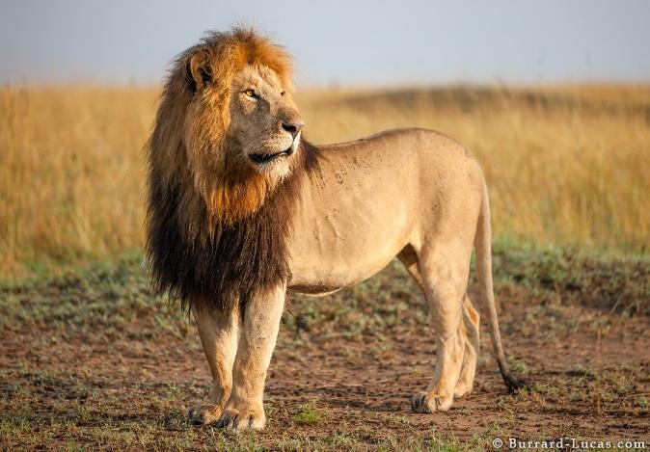**Mane**: A noticeable ridge of hair that extends down top of the neck of, or around the head, an animal. E.g. Lion (mane around head), Blue wildebeest (down neck).

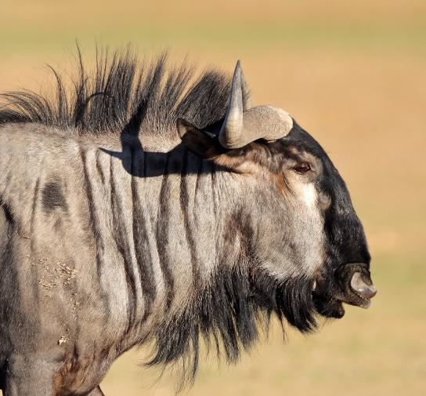

Note that the ridge of hair below the neck of the wildebeest is referred to as a ‘beard’, because of it position.

**Notes**

**Record:** Any other information that is worth mentioning e.g. If there are different colour morphs or multiple sub-species present.